# Project 1 (10%)

## Problem domain: Production of Pascal’s Triangle

The objective of this project is to enable you to apply the concept of abstraction to problem solving. You are required to do the following tasks:

1. Devise a set of algorithms for the given problem domain and represent them using the Algorithmic Definition Language (ADL).
2. Implement the algorithms you devised in (1) systematically in either C# or Java as a console application and test your implementation.
3. A video presentation that showcases the capabilities of software in (2).
4. A descriptive report on any aspect of design and development, including artefacts produced for the project.
5. Produce a short report outlining response to formative feedback.
6. Add your solutions to your portfolio using the portfolio template provided.

This project represents 10% of the total marks available in this module.

**Note that the deadline for completion of this project is the same as the submission date of your portfolio. However, you are advised to complete it by 18th October 2021 (i.e., Week 13) to avoid increasing your workload as other projects will be given out throughout the semester.**

## Binomial coeffients

"In mathematics, *binomial coefficients* are a family of positive integers that occur as coefficients in the binomial theorem."[1]

The quantities n! / k! (n-k)! are the famous *binomial coefficients*, and they are denoted by[2]



Some of their special values are

Description: C:\Users\cmsmo\AppData\Local\Microsoft\Windows\Temporary Internet Files\Content.IE5\56C3N23Q\CodeCogsEqn.gif Description: C:\Users\cmsmo\AppData\Local\Microsoft\Windows\Temporary Internet Files\Content.IE5\56C3N23Q\CodeCogsEqn (1).gif

Description: C:\Users\cmsmo\AppData\Local\Microsoft\Windows\Temporary Internet Files\Content.IE5\24ONGHAA\CodeCogsEqn.gif Description: C:\Users\cmsmo\AppData\Local\Microsoft\Windows\Temporary Internet Files\Content.IE5\56C3N23Q\CodeCogsEqn (2).gif

It is convenient to define Description: C:\Users\cmsmo\AppData\Local\Temp\CodeCogsEqn-1.gifto be zero if k < 0 or if k > n.

## Pascal's Triangle

In the following table, we show the values of some of the binomial coefficients Description: C:\Users\cmsmo\AppData\Local\Temp\CodeCogsEqn-1.gif. The rows of the table are thought of as labelled 'n = 0', n = 1', etc, and the entries within each row refer, successively, to k = 0, 1, 2, …. n. The table is called 'Pascal's triangle'.

1

1 1

1 2 1

1 3 3 1

1 4 6 4 1

1 5 10 10 5 1

1 6 15 20 15 6 1

1 7 21 35 35 21 7 1

1 8 28 56 70 56 28 8 1

Here are some facts about the binomial coefficients:

1. Each row of Pascal's triangle is symmetric about the middle. That is,

Description: C:\Users\cmsmo\AppData\Local\Microsoft\Windows\Temporary Internet Files\Content.IE5\919FMAQR\CodeCogsEqn.gif

1. The sum of the entries in the nth row of Pascal's triangle is 2n.
2. Each entry is equal to the sum of the two entries that are immediately above it in the triangle.

## Grading Criteria

This project will be graded using the criteria given below.

|  |  |
| --- | --- |
| **Criteria** | **Marks** |
| An assessment of understanding and use of algorithmic notation | 25 |
| An assessment of understanding of algorithm design | 40 |
| An assessment of overall software, including testing | 30 |
| Incorporation of formative feedback | 5 |

# Project 2 (15%)

## Problem domain: Algorithmic Complexity and Space-Speed Trade Off

The objective of this project is to enable you to apply the concept of algorithmic complexity to given problems and work out a compromise in a situation where a space-speed trade-off exists. You are required to do the following tasks:

1. Work out the computational complexity of an algorithm.
2. Assess time-space trade-off choices in a problem.
3. Produce a short report outlining response to formative feedback.
4. Add your solutions to your portfolio using the portfolio template provided.

This project represents 15% of the total marks available in this module.

**Note that the deadline for completion of this project is the same as the submission date of your portfolio. However, you are advised to complete it by 25th October 2021 (i.e., Week 14) to avoid increasing your workload as other projects will be given out throughout the semester.**

### Task 1

Consider the following algorithm fragment written in ADL and calculate its computational complexity with justification and represent it in Big-O notation.

**for** i **←** 1 **to** n **by** 1 **do**

**for** j **←** 1 **to** i **by** 1 **do**

**for** k **←** 1 **to** j **by** 1 **do**

x = x + 1

**end**

**end**

**end**

### Task 2

Consider the data shown below, which gives the different flights of an airline. Discuss different ways of storing the data to decrease the time in executing the following:

* Find the origin and destination of a flight, given the flight number.
* Given city A and city B, find whether there is a flight from A to B, and if there is, find its flight number.

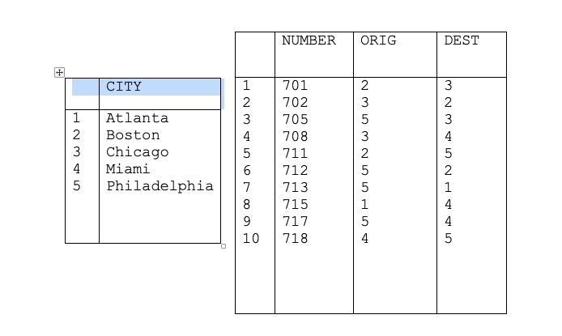

## Grading Criteria

This work will be graded using the criteria given below.

|  |  |
| --- | --- |
| **Criteria** | **Marks** |
| An assessment of time-space trade-off choices | 60 |
| Ability to work out the complexity of an algorithm | 35 |
| Incorporation of formative feedback | 5 |

# Project 3 (20%)

## Problem domain: Priority Queues

The objective of this project is to enable you to apply the concepts of data structure design and implementation. You are required to do the following tasks:

1. Design data structure(s) for the given problem domain.
2. Devise a set of algorithms using the Algorithmic Definition Language (ADL) to manipulate the data structures designed in (i).
3. Implement the algorithms you devised in (2) systematically in either C# or Java as a console application and test your implementation.
4. A video presentation that showcases the capabilities of software in (2).
5. A descriptive report on any aspect of design and development, including artefacts produced for the project.
6. Produce a short report outlining response to formative feedback.
7. Add your solutions to your portfolio using the portfolio template provided.

This project represents 20% of the total marks available in this module.

**Note that the deadline for completion of this project is the same as the submission date of your portfolio. However, you are advised to complete it by 8th November 2021 (i.e., Week 16) to avoid increasing your workload as other projects will be given out throughout the semester.**

### Priority Queue

A *priority queue* is a collection of elements such that each element has been assigned a priority in which elements are deleted and processed comes from the following rules:

1. An element of higher priority is processed before any element of lower priority
2. Two elements with the same priority are processed according to the order in which they were added to the queue.

An example of the use of a priority queue is in a time-sharing operating system: programs of high priority are processed first, and programs with the same priority form a standard queue. There are various ways of maintaining a priority queue in memory. In this project, you are expected to focus on one that uses a linked list. Specifically, in this project, design and implement a priority queue for “job elements” as shown below. Note that the jobs are not in a particular order in this example. In your data structure design, you are required show the beginning and end of the priority queue.

|  |  |
| --- | --- |
| **Job Description** | **Priority** |
| EEE | 4 |
| GGG | 5 |
| CCC | 2 |
| DDD | 4 |
| BBB | 2 |
| FFF | 4 |
| AAA | 1 |

As outlined in the objectives, devise algorithms in ADL as suitable abstractions and implement them that add a job element (i.e., its description and priority), remove a job element and retrieve the priority of a job element given its description. Finally, implement yourt algorithms in either C# or Java as a console application.

This project will be graded using the criteria given below.

|  |  |
| --- | --- |
| **Criteria** | **Marks** |
| An assessment of understanding and use of algorithmic notation | 15 |
| An assessment of understanding of algorithm design | 30 |
| An assessment of data structure design | 30 |
| An assessment of overall software, including testing | 20 |
| Incorporation of formative feedback | 5 |

# Project 4 (25%)

## Problem domain: Designing an Algorithm for an Elevator in Comparison to FIFO Algorithm

The objective of this project is to enable you to design and test a new algorithm for the problem. In this context, you are required to carry out the following tasks:

1. Comprehend and familiarise yourself with the example program provided for the FIFO elevator algorithm.
2. Design a new algorithm for the problem.
3. Run empirical experiments to test the efficiency of your algorithm in comparison to the FIFO elevator algorithm.
4. Analyse results and report your findings in the portfolio.

This project represents 25% of the total marks available in this module.

**Note that the deadline for completion of this project is the same as the submission date of your portfolio. However, you are advised to complete it by 3rd December 2021 (i.e., Week 10) to avoid increasing your workload as other projects will be given out throughout the semester.**

### Background

Elevator scheduling is used in managing elevators operation in buildings. The main objective of the scheduling is to make sure the elevator visits each level request at the least waiting time. There are numbers of algorithms used in elevator operations. The most common one is First In First Out (FIFO) method.

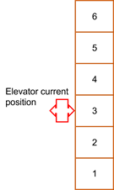

This is an example when there are three level requests.

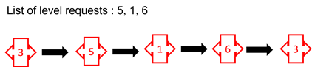

Each level is visited in the FIFO order. The elevator will come back to level 3 when there is no level request.

## Design Your Own Algorithm

In this project you are required to come out with your own (**ONE**) algorithm for the problem. There is no specific algorithm you must use for the work as long as your proposed algorithm outperforms FIFO. The measurement metric to be used is **time in seconds** that a single elevator can complete all level requests. For example,

N = 5. You will have 5 level requests.

Sample = 3. You will have 3 sets of N (different level requests each)

N1 = {3, 4, 6, 8, 9} è 56 seconds

N2 = {9, 5, 3, 6, 3} è 50 seconds

N3 = {2, 1, 3, 6, 3} è 48 seconds

Get the time in seconds to complete these tasks. Record them and get the **average** and **min** values.

Test your algorithm and run empirical experiments for both methods to see the algorithms performance. Your work should be able to satisfy questions/tasks in the Question section.

Questions

1. Demonstrate in writing and/or diagram (or video if necessary) about your elevator algorithm.
2. Present your algorithm in ADL.
3. Write a workable program for your designed algorithm and test the program.
4. Run empirical experiments for both algorithms using sample datasets which are to be designed and produced by yourself. The experiments should have the following set/strategy.

*N* = number of level requests.

|  |  |  |  |  |
| --- | --- | --- | --- | --- |
| *N* | FIFO | | Algo_Zairul | |
| Mean | Min | Mean | Min |
| 5 |  |  |  |  |
| 10 |  |  |  |  |
| 20 |  |  |  |  |
| 25 |  |  |  |  |
| 30 |  |  |  |  |
| 40 |  |  |  |  |
| 50 |  |  |  |  |

Mean and Min (minimum) values are in seconds.

Each *N* experiment should have 10 samples of the experiments to get consistency in results.

1. Write the final results in your portfolio report. Based on your empirical experiment observation, discuss and summarise your work about the algorithm. A video recording may be necessary to present the work.

## Grading Criteria

This project will be graded using the criteria given below.

|  |  |
| --- | --- |
| **Criteria** | **Marks** |
| An assessment of time-space trade-off choices | 10 |
| Ability to work out the complexity of an algorithm | 10 |
| An assessment of understanding of algorithm design | 20 |
| Results Analysis and Discussion | 30 |
| An assessment of data structure design | 20 |
| An assessment of overall software, including testing | 5 |
| Incorporation of formative feedback | 5 |

# Project 5 (30%)

## Problem domain: Implement Genetic Algorithm to the Scale Problem

The objective of this project is to enable you to implement Genetic Algorithm to the paradigm problem. In this context, you are required to carry out the following tasks:

1. Design your Genetic Algorithm (GA) based on the skeleton program provided.
2. Implement your GA for the paradigm problem and run some experiments to answer the research questions outlined in the research question section.
3. Analyse results and report your findings in the portfolio.

This project represents 30% of the total marks available in this module.

**Note that the deadline for completion of this project is the same as the submission date of your portfolio.**

Background

A **genetic algorithm** is a search heuristic method that is inspired by Charles Darwin’s theory of natural evolution. This algorithm reflects the process of natural selection where the fittest individuals are selected for reproduction in order to produce offspring of the next generation.

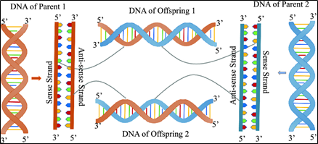

Five phases are considered in a genetic algorithm.

* Initial population
* Fitness function
* Selection
* Crossover
* Mutation

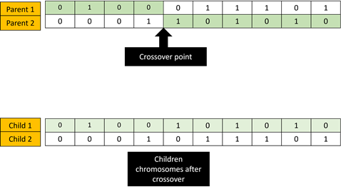

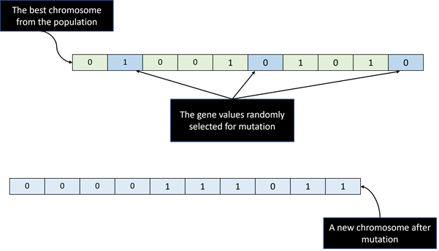

## The Scales Problem

The scales problem is one of the paradigm problems in heuristics and optimisation used to test algorithms.



Suppose you have *n* objects of various weights, and you are required to split those objects into two equally heavy piles (or as equal as possible). Refer [*Problem Solving - Balance a Scale Problem*](https://youtu.be/-n-A5qcO398)for a video explanation.

In this project, you are given with a list of random numbers as the weights.

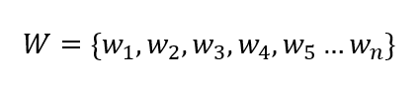

Using Genetic Algorithm, write a program that optimises,



Where,

*L* is the sum of left-hand side weights

*R* is the sum of right-hand side weights

## Genetic Algorithm Representation

We represent the solution as an *n* length binary string/integer where:

* 1. A zero (0) in position *i* means that weight *i* is on the left side of the scales
  2. A one (1) in position *i* means that weight *i* is on the right side of the scales

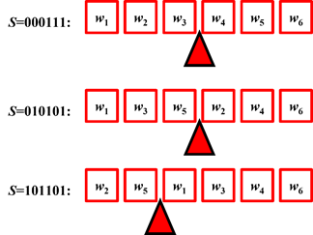

Each solution has its fitness value that computed from the equation. Those solutions with the least fitness values will survive for the next generation. Example:

If your defined population is 10 candidates. The next generation pool will be 10 + reproduction via cross over (2 candidates) + a mutant. Thus, the next generation will have 10 best candidates from those 13.

This process iterates until the number of generation complete.

Instructions

## 

With the skeleton codes and sample dataset provided (**Appendix**), write a program to solve the problem using Genetic Algorithm. Answer the questions in the Research Question section.

Research Questions

1. Design and explain your GA algorithm. Run your algorithm for experimental analysis and demonstrate the results in a table that has maximum, minimum, and mean values of fitness. What are the optima fitness values for the weights?

1. What are the solutions (chromosomes) for question 1? Tabulate the chromosomes and their fitness values in a table. Verify the fitness using a manual calculation (use excel sheet). Provide evident in your report.
2. What are the values used for the following parameters in your experiments,

* Number of generations
* Crossover rate
* Mutation rate

What if you increase and decrease the values? Discuss.

1. Demonstrate in writing and/or pseudocode your crossover strategy for the GA.
2. Demonstrate in writing and/or pseudocode your mutation strategy for the GA. Discuss why mutation is important in GAs?

1. Run empirical experiments to find associate rules of crossover and mutation rates for another dataset of 50 (to be produced from the code provided) weights with the following fitness function,

Where,



*L* is the **product** of left-hand side weights

*R* is the **sum** of right-hand side weights

Analyse and summarise your findings in the report. Plot into graph/s to prove your findings. Discuss your findings.

A video recording to demonstrate the work is part of the marks.

## Grading Criteria

This project will be graded using the criteria given below.

|  |  |
| --- | --- |
| **Criteria** | **Marks** |
| An assessment of understanding of algorithm design | 30 |
| Results Analysis and Discussion | 40 |
| An assessment of data structure design | 20 |
| An assessment of overall software, including testing | 5 |
| Incorporation of formative feedback | 5 |

1. [Wikipedia](http://en.wikipedia.org/wiki/Binomial_coefficient) (<http://en.wikipedia.org/wiki/Binomial_coefficient>)
2. "Algorithms and Complexity", Herbert S. Wilf, Prentice-Hall, 1986, ISBN: 0-13-022054-X.